KSA400 35 LITRE SPIN DRYER

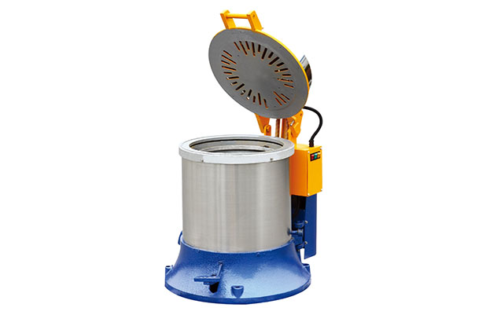

Machine Technical Information

MODEL | KSA400
Weight | 160KG
Dimensions (lxwxh) | 780x600x750mm
Power | 1.8KW+0.75KW
Total Capacity | 35L
Motor Speed (rpm) | 1430
Voltage | 380 V/50-60 Hz
Barrel Speed | 550 r/m
Working Temperature | 30-80°C

